Beginners How to...
by Lidia Higson, RO for Staffordshire and RO Co-Ordinator

INTARSIA
There has been so much talk about intarsia we have included it in this issue’s ‘how to’ – so that you can have a try. If you look in a dictionary the word ‘intarsia’ means, ‘a method of knitting in which a separate length of yarn is used for each area of colour’. Intarsia allows you to use multiple colours in any one row for limitless forms of patterning which can be used to knit abstract or detailed designs or pictures. Some machines have an inbuilt facility for intarsia, others require a separate carriage.

The design is drawn on a chart where one square = one stitch. Usually this is on stitch related graph paper as a
stitch is not square but elongated. On the charts for the apple you can see that the chart on the stitch related graph paper is rounder than the non- related.
The numbers across the bottom of the chart refer to the number of stitches, and the numbers up the side refer to the rows. On the design you will find symbols for the different colours, e.g. xxxx might be lemon, whilst ///// might mean green etc. Always photocopy your design as you might want to use it again, especially if using different colours. Enlarge it if you find the squares difficult to see. Lightly shade in the design in the colours you want to use, so you do not need to keep referring to the symbol chart.
Look at the design and see how many colours you need. For the apple you will need five colours. Red for the main part of the apple, green for shading, lemon for the bite out of the apple, brown for the stalk and a darker green for the leaf. You will also need two cones (balls) of main yarn for the rest of the garment. For small areas, for each colour you can wind some yarn on a bobbin or piece of card, for areas such as eyes a length of yarn may be used. Personally I don’t like the bobbins or card, so I knit up small pieces. I look to see how many stitches and rows an area has e.g. 15sts and 10 rows, so I will knit a piece slightly larger than this e.g. 20sts and 15 rows, (e wrap and just break off). This gives a little weight to the yarn, also as you are knitting, the yarn unravels, where as with bobbins if you do not unravel enough the bobbin gets caught under the gate pegs. If you feel that you need a little extra weight attach a plastic clothes peg.
18
B
e
g
i
n
n
e
r
s

H
o
w

t
o
.
.
.
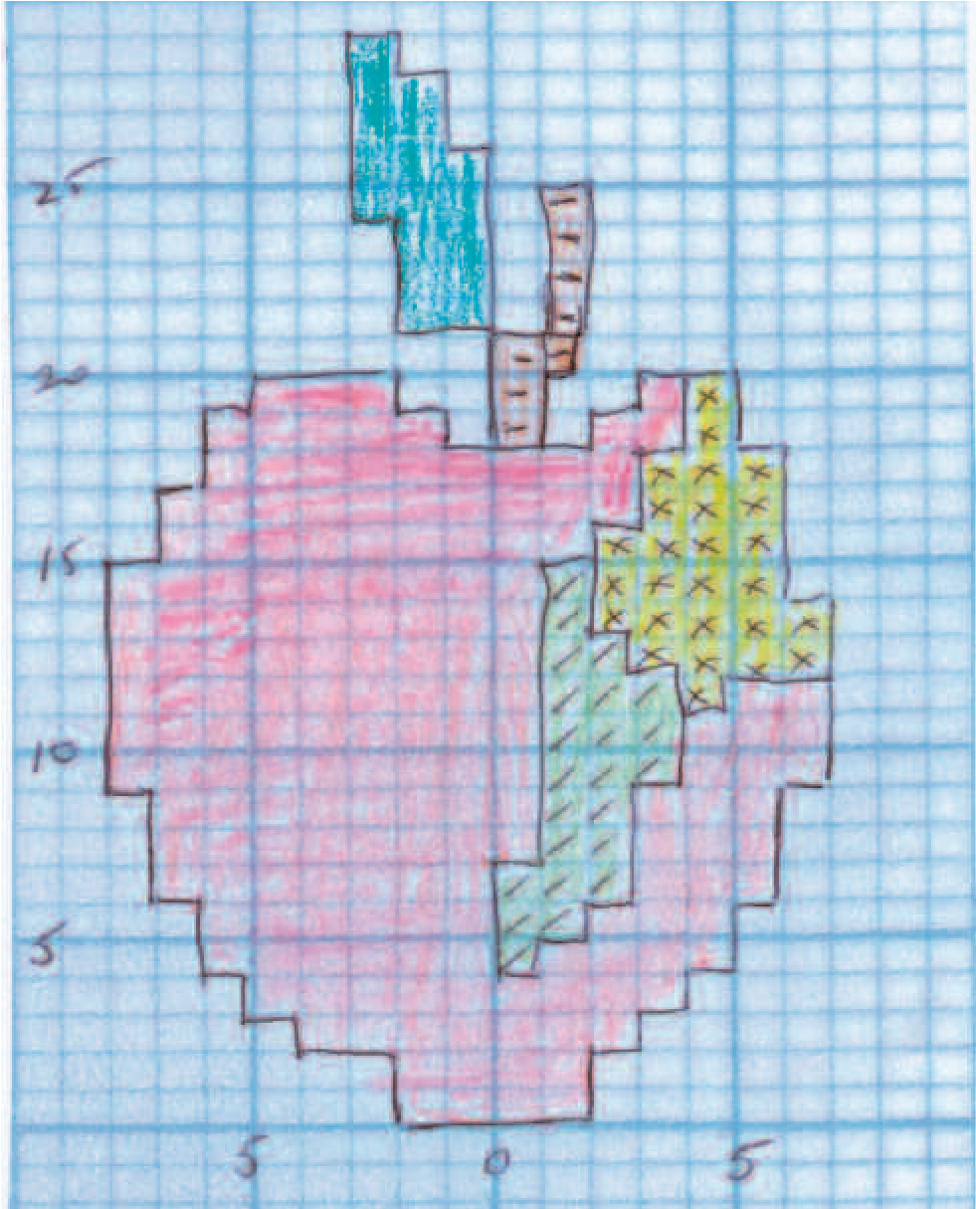
Before starting to knit, practise using the intarsia carriage. You do not need a chart for this, just randomly select the needles, or if you feel more comfortable make a chart on graph paper. It does not need to be stitch related for this. Using the main carriage cast on and knit about ten rows. Hang on weights. End with the carriage on your right and take it off. Do not break the yarn. Take the yarn out of the mast and place it on the floor, (you will be working with yarns either on the floor or on bobbins or small knitted pieces) With needles in ‘B’ (working) position place the intarsia carriage on to the left side of the main bed and take it from left to right (no yarn). This brings the needles to C/D position (upper working position) ready for intarsia. Use the same tension as main carriage. Make sure all the latches are open. You will need to check every row as closed latches mean dropped stitches. Take the yarn and place it over the needles. Gently hold the yarn in your fingers and take the carriage across allowing the yarn to run through your fingers, you are the tension mast. Do this until you are comfortable with it and then introduce another colour. Continue using the two yarns and where they meet twist one over the other. You can then introduce a third colour. Check that the part knitted with the intarsia carriage matches the tension of the main carriage knitting. If the work is tighter then loosen the tension. Once you feel comfortable using three yarns you are ready for a simple design. (At this stage I used to encourage my students to collect small amounts of yarn

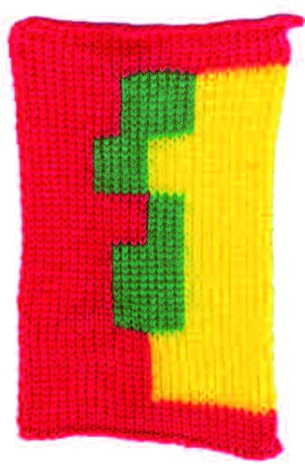
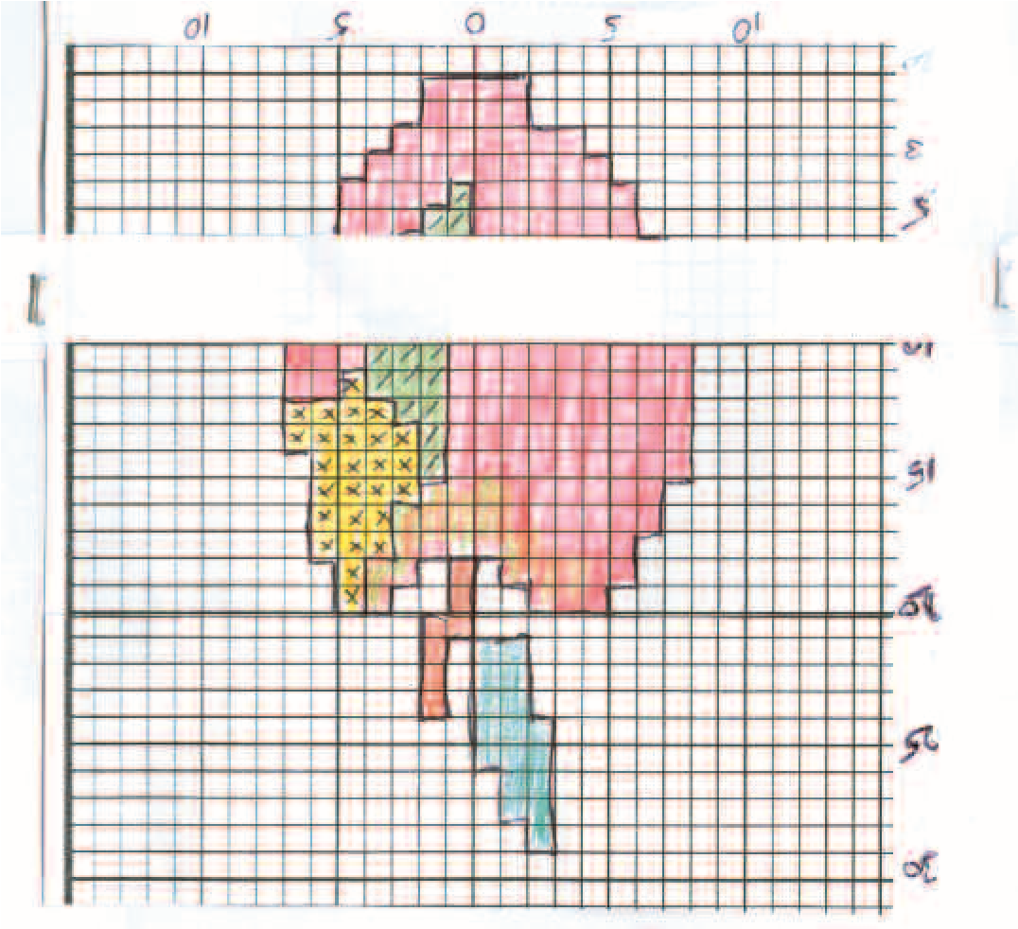
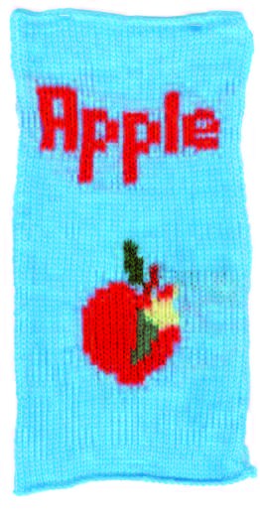
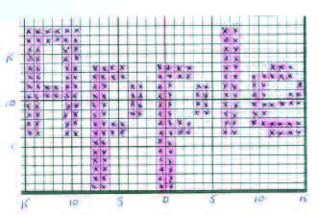
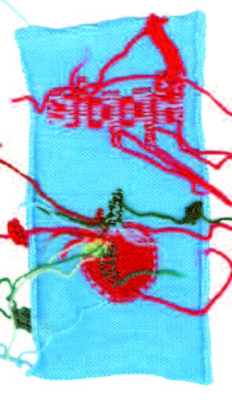
19
B
e
g
i
n
n
e
r
s

H
o
w

t
o
.
.
.
and then to knit the front of a garment, knitting the yarn
at random to get more used to the intarsia carriage. No
charts were used. The results were very varied with one
garment looking as if it had the Pyramids on it.)
Copy and colour in
your design and
prepare the yarn.
Draw a line through
the centre.
Turn
the design upside
down.
This might
seem a funny thing
to do but if you
want the design to
look exactly as on
the chart you must
or
this
do
the
design will be facing
the opposite way
.
Also doing it this
way is easier to knit.
Make
marker
a
using two strips of card or paper, staple the two pieces
at each end so they fit over the chart, but can be moved
up and down. Row one will now be at the top.
Letters and numbers can be drawn as normal.
There is no need to mirror image these. Y
ou only
need to turn them upside down.
Look at the apple
design. Place the
marker under the
first r
ow. You will see
that there are four
stitches for the first
row of the apple and
each side is the main yarn. Start by placing the main
yarn up to the start of the apple, and then you need
four stitches in red and the rest in another ball of main
yarn. Make sure that the latches are open and whilst
holding the ends, take the intarsia carriage across.
Move the marker down to row two. You can still see
row one, so instead of having to count the squares, you
can see that row two is the same as one. Move the
marker to row three; you can see that you need one
stitch extra on the left and two stitches extra on the
right of the apple. Where the yarns meet, twist them to
avoid a hole. Continue in this way changing and
introducing yarns as needed.
When you have finished, you will find that there
are lots of ends at the back. Don’t be alarmed, just
start at one end and weave each piece of yarn
into the knitting.
With the lettering I have cheated a little. As there is
only one stitch between the letters it is possible to carry
the yarn over and under the needles of each colour.
This will create small floats, but it is preferable to eight
pieces of letter colour and ten pieces of background. I
have used separate pieces of blue and red at the
beginning of the chart for the first six rows and also at
the end for the last four rows.
The apple is a simple design and is quite easy to do in
one session. If you want to do a more detailed design,
then if you feel bogged down with it set yourself a
small target such as knitting five rows first, then go
away from it. When you return to it do another three
or fives rows, again walk away. Each time you sit
down to your knitting you will find that you can sit at
it much longer and it gets easier, so you are more
likely to finish it. Happy Knitting.

